**Linkage data**

## Cases by local area in England

url location:

<https://coronavirus.data.gov.uk/cases>

-99 represents count of 0-2. So, we averaged to obtain 1 and replaced all -99s with 1

1. ~~Index of Multiple Deprivation~~

~~Deciles~~

~~url location:~~

[~~https://opendatacommunities.org/resource?uri=http://opendatacommunities.org/data/societal-wellbeing/imd2019/indices~~](https://opendatacommunities.org/resource?uri=http%3A%2F%2Fopendatacommunities.org%2Fdata%2Fsocietal-wellbeing%2Fimd2019%2Findices)

1. ~~File 1: index of multiple deprivation~~

~~url location:~~

[~~https://www.gov.uk/government/statistics/english-indices-of-deprivation-2019~~](https://www.gov.uk/government/statistics/english-indices-of-deprivation-2019)

~~Data contain rank and deciles~~

1. File 2: domains of deprivation

url location:

<https://www.gov.uk/government/statistics/english-indices-of-deprivation-2019>

2019 indices containing individual metrics including health, education

Index of Multiple Deprivation (IMD) Decile (where 1 is most deprived 10% of LSOAs)

IMD Rank (1 is most deprived)

1. 2001 to 2018 edition of this dataset

Public houses and bars by local authority

url location:

<https://www.ons.gov.uk/businessindustryandtrade/business/activitysizeandlocation/datasets/publichousesandbarsbylocalauthority>

Using Pubs size LA 2018 by local authority. Gives number of pubs in uk by local authority

1. 2020 edition of this dataset

UK business: activity, size and location

url location:

<https://www.ons.gov.uk/businessindustryandtrade/business/activitysizeandlocation/datasets/ukbusinessactivitysizeandlocation>

ukbusinessworkbook2020.csv by Retail, Transport_Storage_inc_postal, Accommodation_food services, Education, Health, Arts_entertainment recreation_other_services

1. Local Authority Districts 2019 boundaries

Local Authority Districts in the United Kingdom, as at 31 December 2019. The boundaries available are:

* (BUC) Ultra Generalised (500m) - clipped to the coastline (Mean High Water mark).

<https://geoportal.statistics.gov.uk/datasets/local-authority-districts-december-2019-boundaries-uk-buc>

we use this as cvd cases data is based on 2019 LA boundaries

1. ~~The R number and growth rate in the UK~~

[~~+ show all updates~~](https://www.gov.uk/guidance/the-r-number-in-the-uk#full-history)

~~url:~~

[~~https://www.gov.uk/guidance/the-r-number-in-the-uk~~](https://www.gov.uk/guidance/the-r-number-in-the-uk)

~~we imputed missing values for R number for wk_5 to wk_12 using R values average from wk_22 to wk_30. We imputed growth rate values for wk_5 to wk_12 using growth rate average from wk_25 to wk_33. We model wk_13 to wk_20 R number based on R value trend from wk_37 to wk_41. We model wk_13 to wk_20 growth rate based on growth rate values from wk_33 to wk_41. This is based on visual assessment based on shaped and distribution of cases count from sampled Local authority regions.~~

1. Local Authority District to Public Health England Centre to Public Health England Region (December 2019) Lookup in England

url:

<https://geoportal.statistics.gov.uk/datasets/local-authority-district-to-public-health-england-centre-to-public-health-england-region-december-2019-lookup-in-england>

1. Mid-2019: April 2019 local authority district codes edition of this dataset

Population estimate data

url: <https://www.ons.gov.uk/peoplepopulationandcommunity/populationandmigration/populationestimates/datasets/populationestimatesforukenglandandwalesscotlandandnorthernireland>

using the following sheets: MYE2 – Males, MYE2 – Females, MYE3 (migrationFlow), MYE2 – Persons (contains age population).

1. School_Opening

url:

<https://www.gov.uk/government/publications/actions-for-schools-during-the-coronavirus-outbreak/guidance-for-full-opening-schools>

<https://www.bbc.co.uk/news/uk-51952314>

Schools have remained open to some pupils since 23 March, welcoming more pupils back from 1 June.

1. Number of monthly arrivals in tourist accommodation in Spain from August 2018 to July 2020*

url:

<https://www.statista.com/statistics/1130775/number-of-monthly-arrivals-short-stay-accommodation-in-spain/>

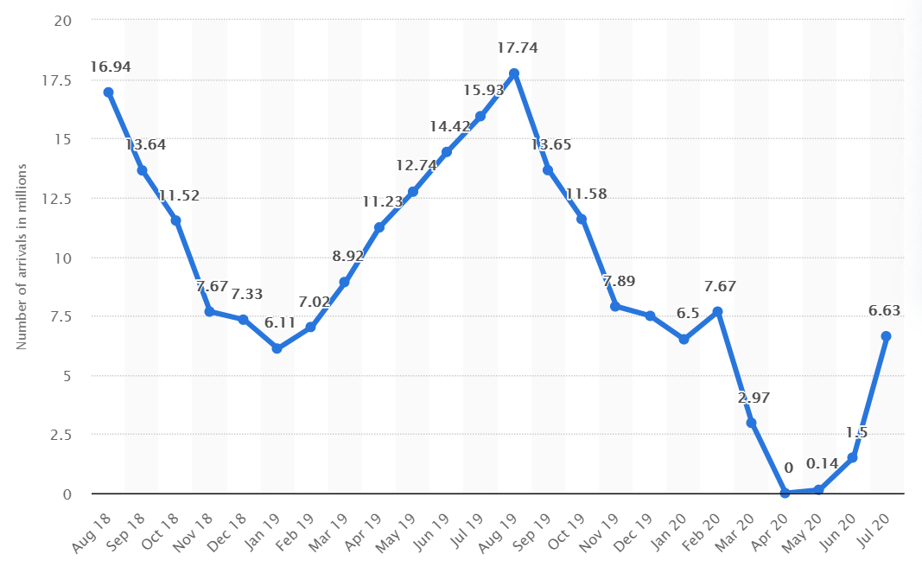

We adjust tourist arrival by 13. Proportion of UK citizens in 2019

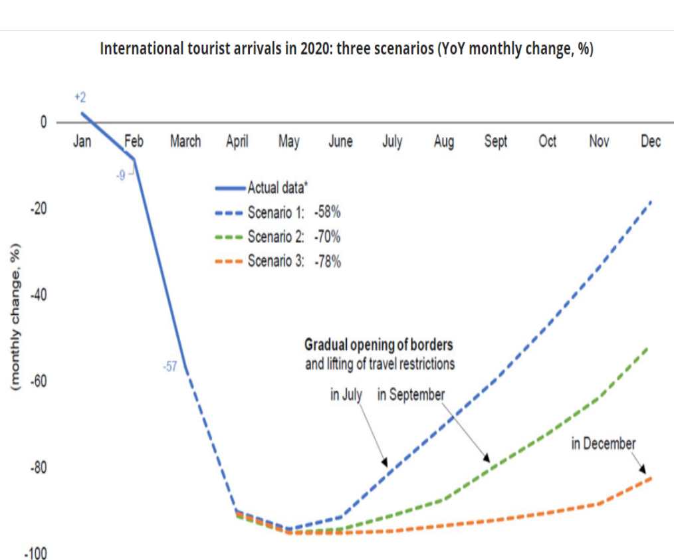

url: https://www.adpr.co.uk/blog/covid-19/travel-and-tourism-brands-can-recover-from-coronavirus/

As UK removed 75 countries from quarantine list in July, we impute missing values from August to October based on the recovery model for July opening of borders above. However, the actual recovery based on the data is much faster than that shown in figure above.

1. Number of international tourists arriving in Spain in 2019, by country of residence

url:

<https://www.statista.com/statistics/447683/foreign-tourists-visiting-spain-by-country-of-residence/>

obtains proportion of UK citizens arriving in Spain in 2019 as estimate for proportion in 2020

statistic_id447683_international-tourist-arrivals-in-spain-2019-by-country-of-residence.xlsx

UK proportion: 0.215984348

1. Weekly deaths with COVID-19 on the death certificate by date registered

url:

<https://coronavirus.data.gov.uk/deaths?areaType=nation&areaName=England>

Data is added to unformattedWeeks.csv

1. Public Health England Centres (December 2016) Ultra Generalised Clipped Boundaries in England

url:

<https://geoportal.statistics.gov.uk/datasets/public-health-england-centres-december-2016-ultra-generalised-clipped-boundaries-in-england>

2016 is the latest available

1. QuarantineMeasures

url:

<https://webcache.googleusercontent.com/search?q=cache:J8RTskJUc0QJ:https://www.theweek.co.uk/107044/UK-coronavirus-timeline+&cd=4&hl=en&ct=clnk&gl=uk>

The QuarantineMeasures column score within unformatWeeks datasheet is based on the dates of quarantine policy changes and perceived magnitude of change.

1 for no quarantine. 10 for full quarantine. 5 for removal of 59 countries for quarantine list. 5.5 for adding Spain back to the quarantine list.